Heritable variation?

Look at the drawings of the two men.
Some examples of variation between them have been labelled.
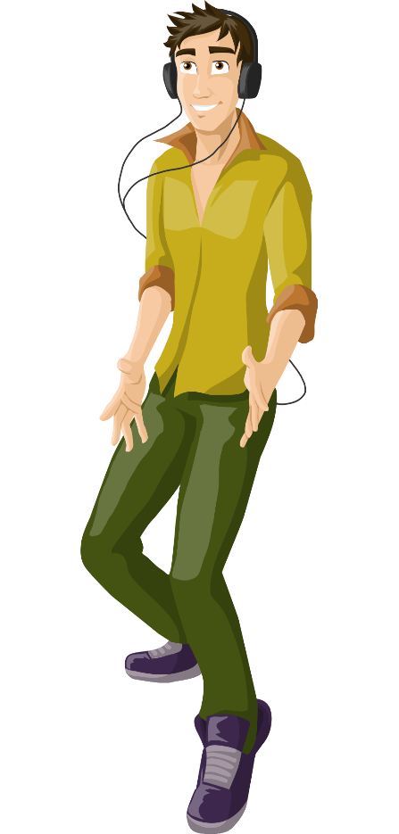
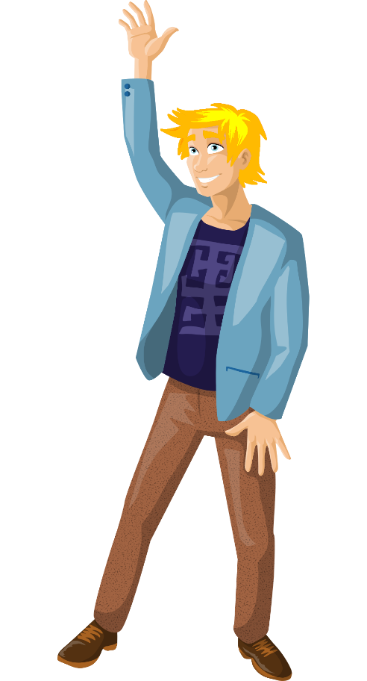
hair colour
eye colour
tall

scar
short

Answer the questions for each example of variation.

- Which statement is true for the feature?
A | The variation will definitely be passed on to their children.
B | The variation may be passed on to their children.
C | The variation will not be passed on to their children.

- How would you explain your answer to question 1?
A | It is caused only by the environment.
B | It is caused only by genetic information in the genome.
C | It is affected by genetic information in the genome and by the environment.

Biology > Big idea BVE: Variation, adaptation and evolution > Topic BVE3: Evolution > Key concept BVE3.1: Explaining evolution
Diagnostic question
Heritable variation?

Overview
Learning focus: | The characteristics of a species can change over generations as advantageous adaptations become more common; this is evolution, and can be explained by a process of natural selection.
Observable learning outcome: | Recognise that there is variation between individuals within a species, and that only genetic variation can be inherited.
Question type: | Two-tier multiple choice
Key words: | variation, heredity, genome

What does the research say?
Research reported by a number of authors (Driver et al., 1994; Williams, 2012; Cisterna, Williams and Merritt, 2013; Allen, 2014) suggests that children up to age 11 have numerous misunderstandings about the inheritance of characteristics from one generation to the next, including that acquired characteristics (variation resulting from interaction with the environment or from learning) can be passed from parents to offspring (Lamarckism).
Gregory (2009) summarises numerous studies in which it was found that when students of various ages were asked to explain evolution by natural selection, very few explicitly included ideas about variation within species (a fundamental requirement for evolution by natural selection, in which the natural variation within populations of a species can cause some individuals to have a survival and therefore reproductive advantage when environmental conditions change).
In order to explain evolution using ideas about natural selection, students must appreciate that only genetic variation can be inherited.
Ways to use this question
Students should complete the questions individually. This could be a pencil and paper exercise, or you could use the PowerPoint presentation with an electronic voting system or mini white boards.
The answers to the questions will show you whether students understand that variation includes both inherited and acquired characteristics, and that acquired characteristics (caused by lifestyle or the environment) cannot be passed on to offspring.
Differentiation
You may choose to read the questions to the class, so that everyone can focus on the science. In some situations it may be more appropriate for a teaching assistant to read for one or two students.
Expected answers
Tall/short
- B – The variation may be passed on to their children
- C – It is affected by genetic information in the genome and by the environment.

Hair colour
- B – The variation may be passed on to their children
- C – It is affected by genetic information in the genome and by the environment.
Eye colour
- A – The variation will definitely be passed on to their children
- B – It is caused only by genetic information in the genome.
Scar
- C – The variation will not be passed on to their children
- A – It is caused only by the environment.
How to respond - what next?
If there is a range of answers, you may choose to respond through structured class discussion. Ask one student to explain why they gave the answer they did; ask another student to explain why they agree with them; ask another to explain why they disagree, and so on. This sort of discussion gives students the opportunity to explore their thinking and for you to really understand their learning needs. Responses often work best when the activities involve paired or small group discussions, which encourage social construction of new ideas (meaning making) through dialogue.
If students have misunderstandings about the inheritance of characteristics from one generation to the next, including that acquired characteristics (variation resulting from interaction with the environment or from learning) can be passed from parents to offspring, the following BEST ‘response activity’ could be used in follow-up to this diagnostic question:
- Response activity: Can it be inherited?
Acknowledgments
Developed by Alistair Moore (UYSEG).
Images: adapted by UYSEG from pixabay.com/GraphicMama-team (1454440; 1458632)
References
Allen, M. (2014). Misconceptions in Primary Science, Second edn Berkshire, UK: Open University Press.
Cisterna, D., Williams, M. and Merritt, J. (2013). Students' understanding of cells & heredity: patterns of understanding in the context of a curriculum implementation in fifth & seventh grades. American Biology Teacher, 75(3), 178-184.
Driver, R., et al. (1994). Making Sense of Secondary Science: Research into Children's Ideas, London, UK: Routledge.
Gregory, T. R. (2009). Understanding natural selection: essential concepts and common misconceptions. Evolution: Education and Outreach, 2, 156-175.
Williams, J. M. (2012). Children and adolescents' understandings of family resemblance: a study of naïve inheritance concepts. British Journal of Developmental Psychology, 30(2), 225-252.

